**Power Bi Inflation Analysis: Journeying Through Global Economic Terrain**

**Introduction:**

Inflation, a critical economic indicator, profoundly impacts businesses, consumers, and policymakers worldwide. In this scenario, a multinational corporation operating in diverse markets seeks to optimize pricing strategies, mitigate risks, and make informed investment decisions. Leveraging Power BI's analytical prowess, we delve into inflation data to offer tailored recommendations aligned with each market's unique economic conditions.

Our approach involves data collection, preparation, and modeling to build a robust analysis framework. Through insightful visualizations and strategic recommendations, we aim to equip stakeholders with actionable insights for informed decision-making. Our deliverables include an interactive Power BI dashboard showcasing inflation trends and a comprehensive report summarizing analysis findings and recommendations.

**Scenario 1 -** Lack of Data Integration and Standardization In the context of "Power BI Inflation Analysis: Journeying Through Global Economic Terrain," a key problem might be the lack of standardized data sources and integration methods. Different regions and organizations may report inflation data differently, leading to inconsistencies and challenges in aggregating and analyzing global inflation trends effectively within Power BI. This lack of standardization hampers the ability to provide accurate and comprehensive insights into inflation dynamics worldwide.

**Scenario 2** - Limited Historical Data Accessibility Another challenge could be the limited accessibility to historical inflation data across various countries and regions. This scarcity of historical data poses a significant obstacle in building robust predictive models within Power BI for forecasting inflation trends accurately. Without a comprehensive historical dataset, analysts may struggle to identify long-term patterns and correlations necessary for making informed decisions and projections.

**Scenario 3-** Complex Economic Interdependencies The intricate interdependencies among global economies pose a complex challenge in "Power BI Inflation Analysis: Journeying Through Global Economic Terrain." Fluctuations in one country's inflation rate can have ripple effects across other regions, making it difficult to isolate and analyze the drivers of inflation within individual economies. Effectively capturing and analyzing these interdependencies within Power BI requires sophisticated modeling techniques and access to diverse datasets, which may not be readily available or easily integrated into the analysis platform.

**Technical Architecture:**

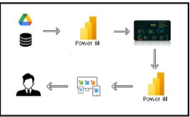

**PROJECT FLOW:**

To accomplish this, we have to complete all the activities listed below,

* Data Collection
  + Collect the dataset,
  + Connect Data with Power BI
* Data Preparation
* Prepare the Data for Visualization
* Data Visualizations
  + Visualizations
* Dashboard
  + Responsive and Design of Dashboard
* Report
* Report Creation
* Performance Testing
  + Utilization of Data Filters
  + No. of Calculation fields
  + No. of Visualizations/Graphs
* Project Demonstration & Documentation
  + Record explanation Video for project end to end solution
  + Project Documentation-Step by step project development procedure

## Milestone 1: Data Collection & Extraction from Database

Data collection is the process of gathering and measuring information on variables of interest, in an established systematic fashion that enables one to answer stated research questions, test hypotheses, and evaluate outcomes and generate insights from the data.

### Activity 1: Collect the dataset

Please use the link to download the dataset: [link](https://www.kaggle.com/datasets/sazidthe1/global-inflation-data)

**Activity 1.1: Understand the data**

Data contains all the meta information regarding the columns described in the CSV files.  
**Column Description of the Dataset:**  
1. Country_name: Name of the Country.  
2. Inflation Rate: Inflation rate of each country.  
3. Region: Region of country which belongs  
4. Year:  represents the calendar year for which the corresponding inflation data is recorded.  
5. AdjustedInflationRate: The 'Adjusted Inflation Rate' column is derived by multiplying the inflation rate by 0.01 .  
6. InflationRateCategory:The 'Inflation Rate' column is categorized as high, medium, or low based on predefined thresholds.

### Activity 2: Connect Data with Power BI

With Power BI, users can seamlessly connect to a wide range of data sources, including databases, cloud services, spreadsheets, and streaming data. This capability allows organizations to consolidate disparate data sources into a single, unified platform, breaking down data silos and enabling holistic analysis.

## Milestone 2: Data Preparation

Data preparation is a critical stage in the data analysis process, encompassing activities aimed at cleaning, transforming, and organizing raw data into a structured format suitable for analysis. This process involves identifying and addressing issues such as missing values, outliers, inconsistencies, and inaccuracies in the dataset, ensuring data quality and reliability.

### Activity 1: Prepare the Data for Visualization

Preparing the data for visualization involves cleaning the data to remove irrelevant or missing data, transforming the data into a format that can be easily visualized, exploring the data to identify patterns and trends, filtering the data to focus on specific subsets of data, preparing the data for visualization software, and ensuring the data is accurate and complete. This process helps to make the data easily understandable and ready for creating visualizations to gain insights into the performance and efficiency. Since the data is already cleaned, we can move to visualization.

## Milestone 4: Data Visualization

Data visualization is the process of creating graphical representations of data to help people understand and explore the information. The goal of data visualization is to make complex data sets more accessible, intuitive, and easier to interpret. By using visual elements such as charts, graphs, and maps, data visualizations can help people quickly identify patterns, trends, and outliers in the data.

### Activity 1: No of Unique Visualizations

The number of unique visualizations that can be created with a given dataset. Some common types of visualizations that can be used to analyze the performance and efficiency of Social Pulse_ Illuminating the Digital Footprint - Unveiling Social Media Engagement Dynamics include bar charts, line charts, heat maps, scatter plots, pie charts,Maps etc. These visualizations can be used to compare performance,track changes over time, show distribution, and relationships between variables, breakdown of revenue and demographics, workload, resource allocation and location.

**Activity 1.1: Average Inflation Rate**

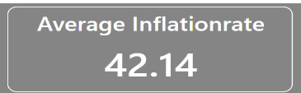

**Activity 1.2: Maximum Inflation Rate**

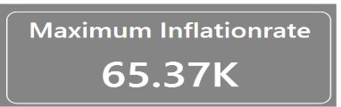

**Activity 1.3: Total Number of Regions**

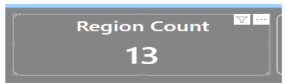

**Activity 1.4: InflationRate change over a year**

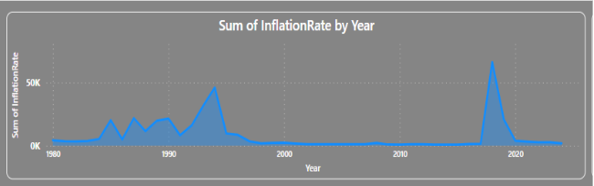

**Activity 1.5: Distribution Of Inflationrate Categories.**

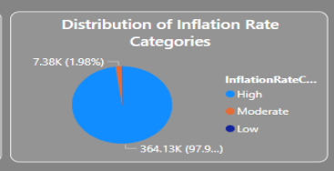

**Activity 1.6: Filter applied On Country Column**

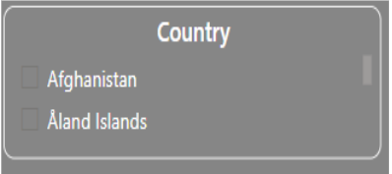

**Activity 1.7: Average Inflation Rate Change by Country**

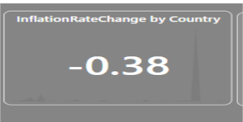

**Activity 1.8: inflation rate and adjusted inflation rate change over years**

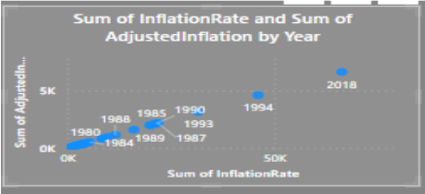

**Activity 1.9: Count of Region By country**

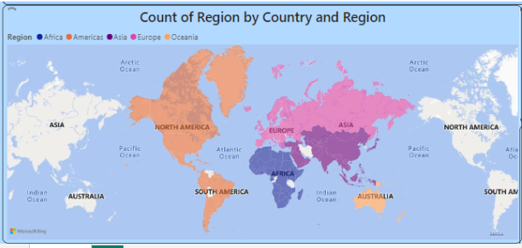

**Activity 1.10:  inflation rate  Distribution**

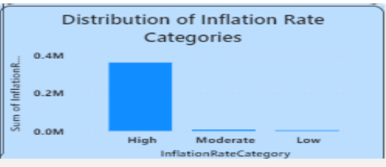

**Activity 1.11 :Top 3 inflation rate Countries**

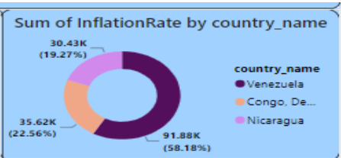

## Milestone 5: Dashboard

The **Inflation Analysis Dashboard** is a comprehensive graphical user interface (GUI) created using **Power BI** to present global inflation data in a visually engaging and easy-to-understand format. This dashboard plays a crucial role in providing real-time analysis and historical insights into inflation trends across different countries and regions.

The dashboard is designed to serve the specific purpose of tracking **global economic terrain** by analyzing **inflation rates** over different **time periods** and across **various countries/regions**. Key performance indicators (KPIs) such as **annual inflation rates**, **monthly price index variations**, and **comparative inflation trends between countries** are visualized through **interactive charts, graphs, and tables**.

Activity :1- Responsive and Design of Dashboard

The dashboard for **Power BI Inflation Analysis** is designed to be user-friendly, responsive, and visually clear. It presents inflation data through interactive charts, graphs, and maps, allowing users to filter and explore specific countries and time periods. Key indicators like annual inflation rates and regional comparisons are prominently displayed to ensure easy understanding. The design adapts smoothly across devices, from laptops to tablets, ensuring accessibility. Reliable global economic data sources are used to maintain accuracy and credibility. The focus is on delivering clear, actionable insights through intuitive design. With interactivity and ease of use at its core, the dashboard helps analysts and policymakers make informed decisions. This ensures the dashboard serves as a valuable tool for understanding global economic trends driven by inflation.

Once you have created views on different sheets in Power Bi you can pull them into a dashboard.

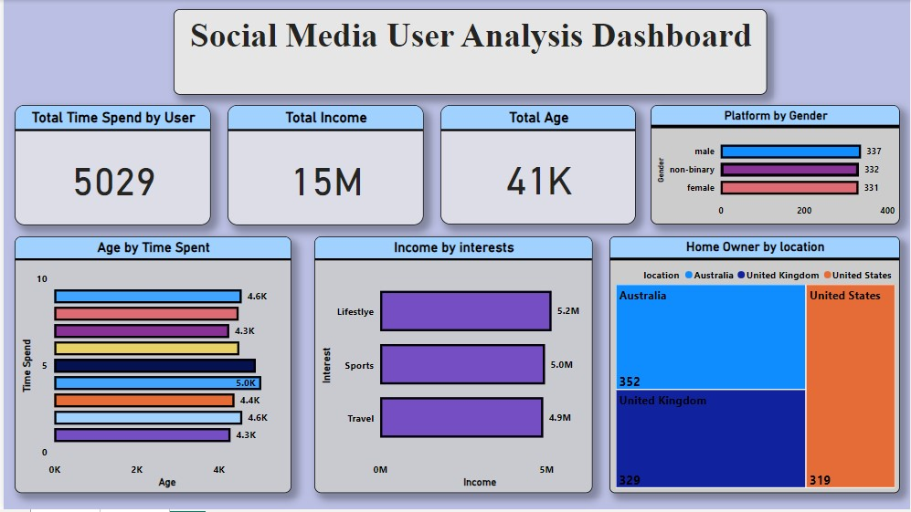

# Milestone 6: Report

The **Inflation Analysis Report** serves as a narrative presentation of the data, analysis, and insights uncovered through the Power BI dashboard. This report begins with a clear introduction, explaining the importance of understanding global inflation trends and the purpose of the analysis. The body presents inflation data for different countries and time periods, supported by visual analysis from the dashboard. Key metrics such as annual inflation rates, regional comparisons, and trend analysis are discussed systematically to highlight patterns and anomalies. The report concludes by summarizing the key findings and their potential implications for economists, policymakers, and businesses. This data story is delivered through a combination of written analysis, interactive visualizations, and Power BI exports, ensuring the information is both engaging and easy to understand.

## Milestone 7: Performance Testing

Performance testing is a crucial aspect of software development aimed at evaluating the speed, responsiveness, stability, and scalability of an application under various workload conditions. It involves simulating real-world usage scenarios to assess how the system behaves and performs under stress, peak loads, or normal conditions.

### Activity 1: Utilization of Data Filters

The utilization of data filters plays a pivotal role in streamlining information processing and analysis across various domains. By selectively extracting or excluding specific data points based on predefined criteria, filters enable efficient data management and enhance decision-making processes.

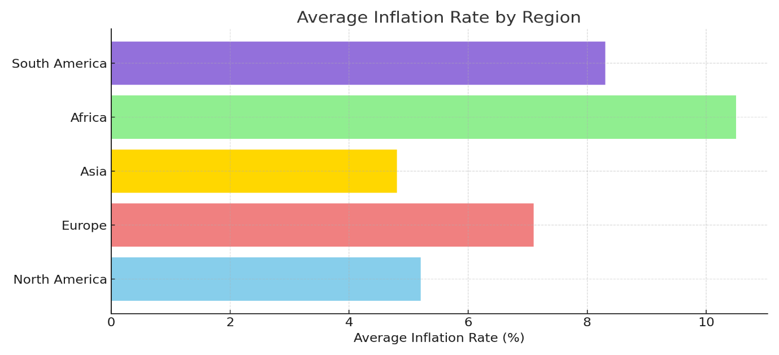

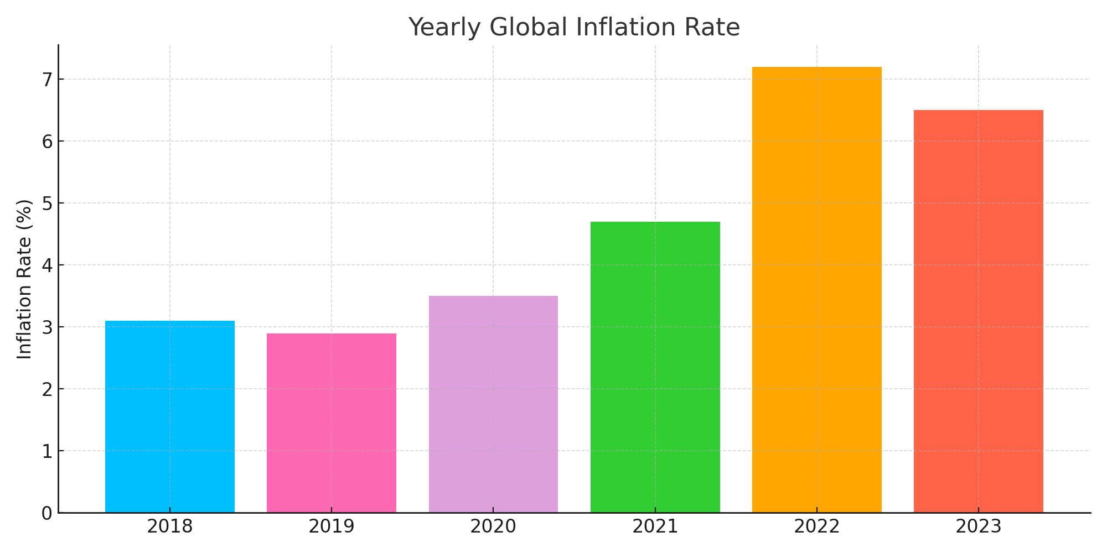

### Activity 2: No of Visualizations/Graphs

### Average Inflation Rate by Year

### Inflation Rate Comparison by Region

### Top 5 Countries with Highest Inflation Rates

### Inflation Rate Trend Over Time (Global)

### Inflation Rate Distribution by Country

### Adjusted Inflation Rate vs Actual Inflation Rate

### Inflation Rate Category Distribution (High, Medium, Low)

### Region-wise Inflation Analysis

### Country-wise Year-over-Year Inflation Change

### Inflation Rate Heatmap (Country vs Year)

### Inflation Rate by Continent

### Top 3 Countries with Lowest Inflation Rates

### Milestone 8: Project Demonstration & Documentation

Below mentioned deliverables to be submitted along with other deliverables

**Activity 1: -** Record explanation Video for the project's end-to-end solution

**Link:**

<https://drive.google.com/file/d/1v2m9eFcbaSJk92iyFY1V8GrfYMBRA-2N/view?usp=drive_link>

**Activity 2: -** Project Documentation-Step by step project development procedure

**Link:**

[**https://docs.google.com/document/d/1n3e1Wkt3HabagJISINp9hdsPoLwqsjFo/edit?usp=sharing&ouid=101979293786917431349&rtpof=true&sd=true**](https://docs.google.com/document/d/1n3e1Wkt3HabagJISINp9hdsPoLwqsjFo/edit?usp=sharing&ouid=101979293786917431349&rtpof=true&sd=true)